**Contents**

Introduction……………………………………………………………………….

Team Members………………………………………………………………….

Roles………………………………………………………………………………….

Gantt Chart…………………………………………………………………………

Main Work Screenshots…………………………………………………….

Conclusion………………………………………………………………………….

## 

## **INTRODUCTION**

With the help of agile mythology, we create an android application on Blood Donor Manager. In this app, user can create multiple account by simply register himself/herself on app and maintain the list of donor list based upon active user. List of donor provide call feature, email feature, add the new donor to list as well as delete the donor information.

# **TEAM MEMBERS**

**1. Akshay**

**2. Gaurav**

**3. Anmol**

## **ROLES**

**Akshay**: Product Owner

**Gaurav**: Scrum Master and Stakeholder

**Anmol**: Developer

## **GANTT CHART**

## **Main Work** **SCREENSHOT**

User Table Screen Shot

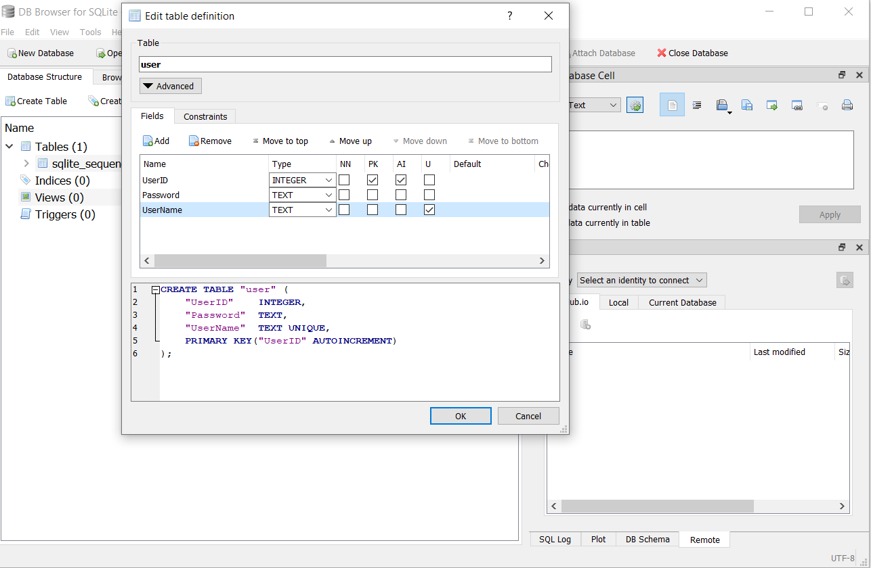

Donor Table Screen Shot

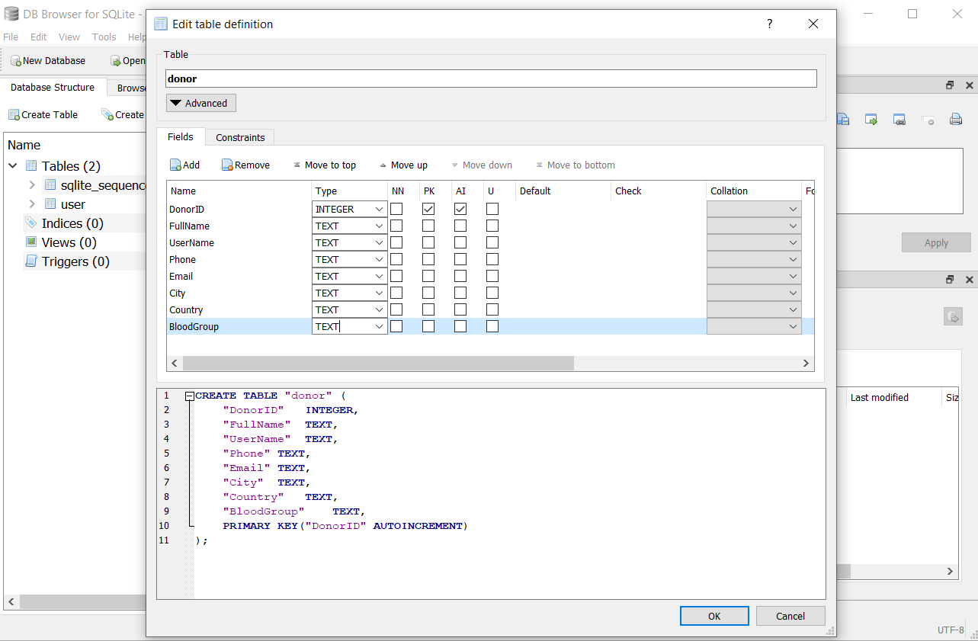

Login Screen:

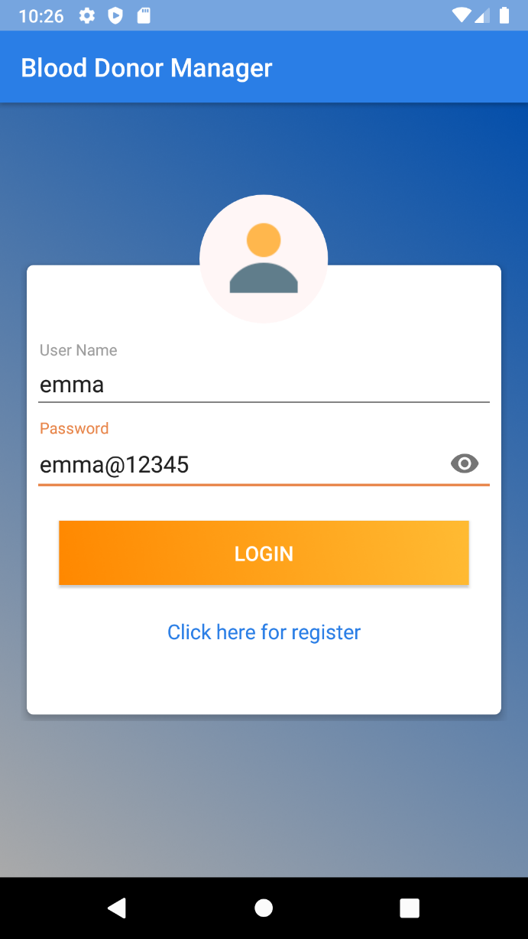

Register Screen:

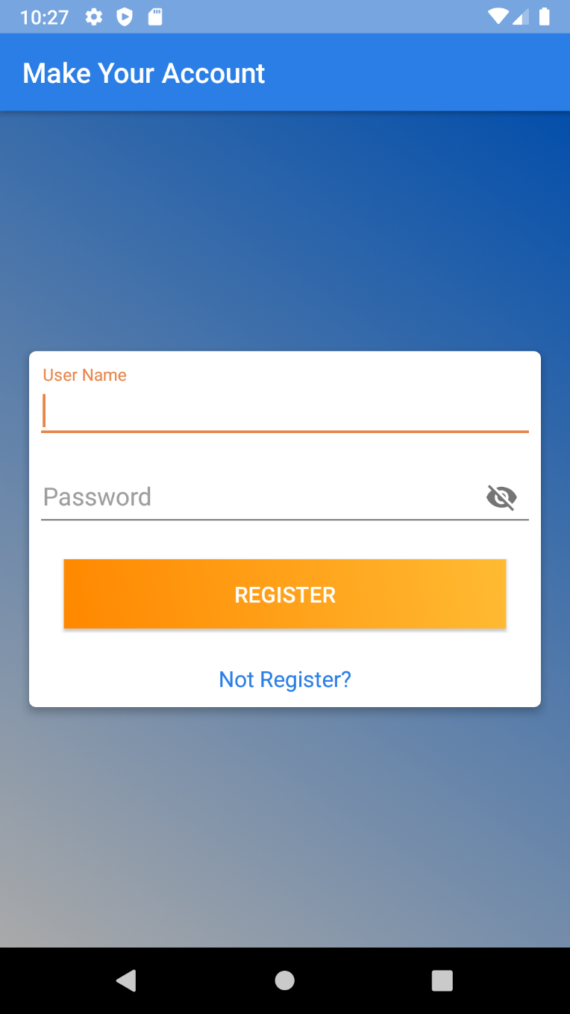

Blood Donor Dashboard

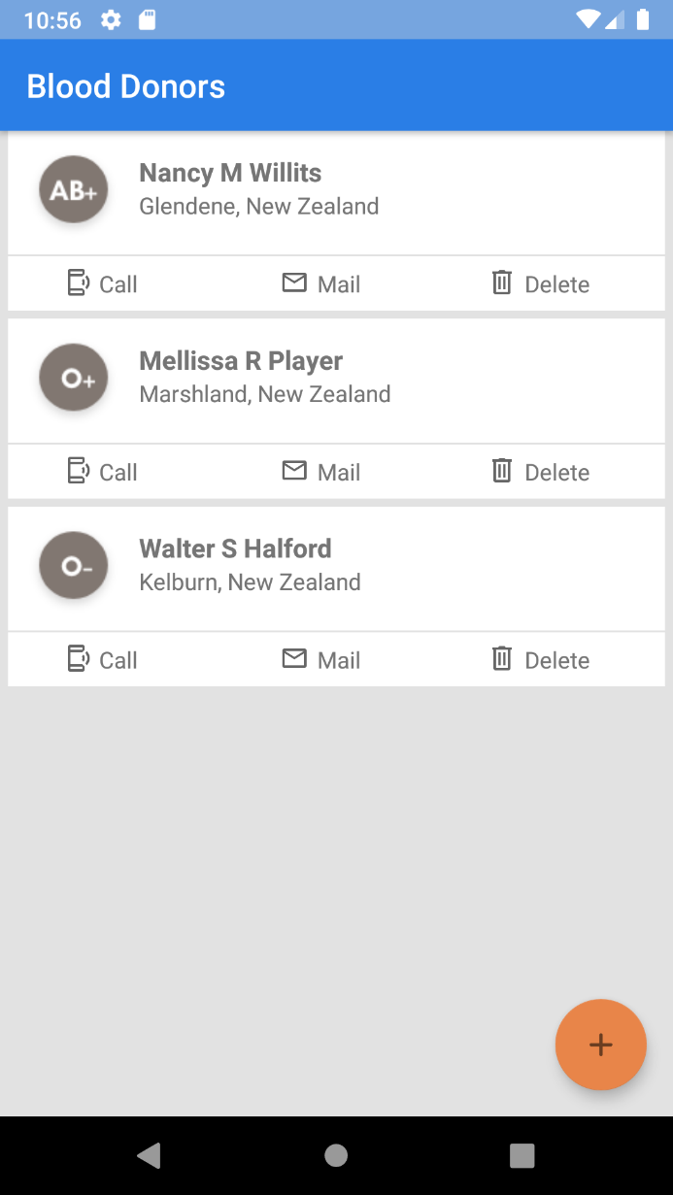

Add Donor Fragment Screen

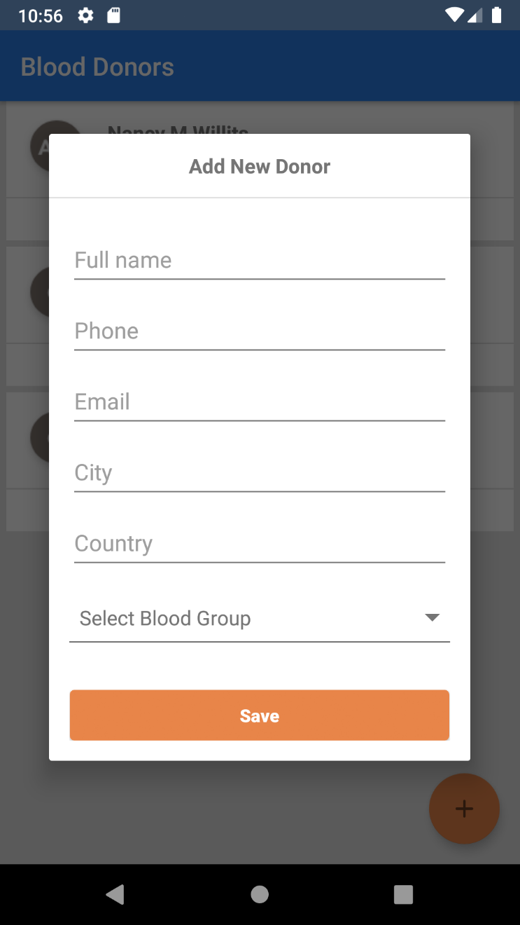

Call Feature Screen

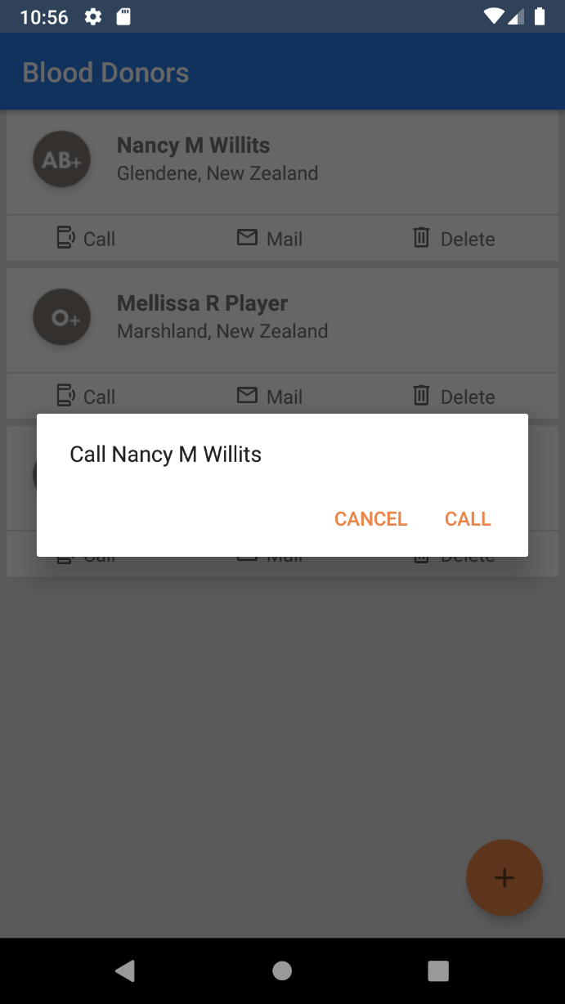

Mail Sending Feature Screen

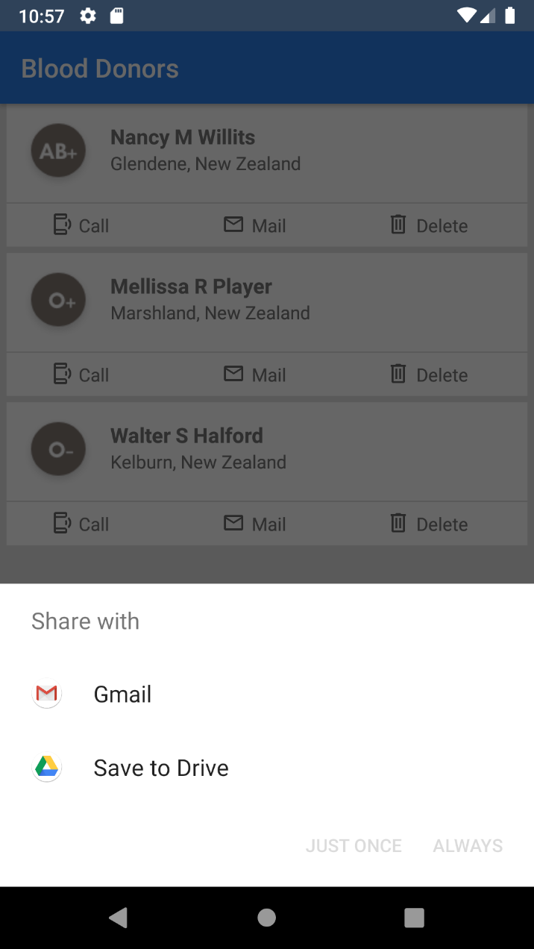

## **Conclusion**

Agile and scrum methodology are used by the project managers for keeping the track of work. As it quickly reacts to changes and is more flexible as compared to others.

To sum up, this application is for personal use of a user to maintain its own list of persons which are willing to donate blood. This application provides a better way to organize the list of blood donor with the feature of calling and sending email.